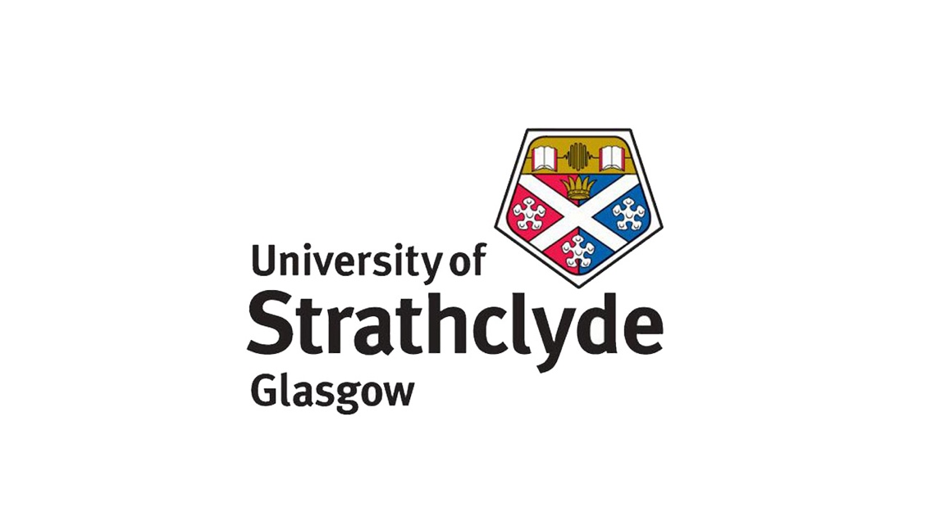

**MG209 Assignment:**

**Corporate Structure: New World Trading**

*Essay of Analysis*

**Lewis Britton {201724452}**

MG209: Organisational Analysis & Strategy

November 2018

Word Count: {2493}

**Corporate Structure: New World Trading Co.**

*Introduction*

The New World Trading Co. (NWTCo.) is the parent company of a range of brands offering primarily culinary service such as rustic dining, classic-style bars, and premium, hotel dining (NWTCo., 2018). All with the recurring theme of botany. They have locations all around England which appeal to many different types of consumer. Relative to the geographical location, area history and recurring themes.

*Background*

NWTCo., since only 2011, have grown a huge brand and name. Founded by Jeremy Roberts and Tim Bacon, with the passion for their multi-award-winning bars and restaurants, they have been able to expand into a range of culinary offerings over England. Based from their headquarters in beautiful Knutsford, Cheshire. From there, they manage their seven brands: The Club House, The Trading House, The Botanist, The Oast House, The Florist, The Canal House and Smugglers Cove. In 2014, they secured investment form Lloyds banking Group worth £2.2m, reflecting this investment in great expansion initially over England (Sutton, 2017) (Source 1). Following its success, but the unfortunate death of co-founder Tim Bacon, the company was sold to Graphite Capital for £50m in 2016 and since, has received additional investment of £23m form NatWest (Sutton, 2017) (Source 1). And business can only be seen as exponentially growing. As well as staff pleasure. This has been certified in their nine awards of 2018, so far.

*Bridge*

NWTCo.’s development in structural components such as cultural relations, evolution and, strategy, can be analysed by looking at these factors from perspectives such as their brands, values, sources, inputs/outputs, supply/demand, locations, opportunities and, threats etc. Analysable using methods such as PESTLE analysis, Porter’s 5 Forces and other miscellaneous analytical sources. First, it’s necessary to identify the general structure and nature of the company its-self.

*Introduction to Structure*

New World Trading Co. is a parent company which controls and is directly linked to its brands as independent entities. Therefore, suggesting NWTCo. adopts an “M” form (Chandler, 1962). Meaning, in this case, they are organised around the product, in terms of what service, they will offer; market/region: in terms of what the class/style of person will be in the radial vicinity want, etc. Chandler, 1962). The company is standard, it has a CEO and board of directors who make decisions and oversee the divisional structure. Splitting each of the seven brands individually into groups of attributes relative to this.

And so, one type of structure, which is effective for one range of business, is not necessarily the most effective for another (Ackroyd, 2002). That is, the required structure and tailoring adapts and changes relative to the different target markets throughout the seven brands, relative to the environment (Lawrence & Lorsch, 1967). This could involve interior design, uniform, employee attitude/nature, atmospheric tailoring, etc. For example, The Club House is tailored to the more elegant and, even, extravagant diner. Due to factors such as price and quality etc. (NWTCo., 2018). Whereas, The Florist is their least formal brand seen in the rugged, organic nature. But as can be seen by the product offered, that is, well garnished, Villeroy & Boch like glassware etc., the same business principal is applied, meaning it is still structured and regimented efficiency while, the factors such as uniform, atmosphere etc., are far more tailored to the more relaxed customer. Hence, with regards to the “mechanistic and organic” business structures (Burns and Stalker, 1967), it is shown NWTCo. adopt an organic structure. Due to the genuine flexibility, relaxation and trust in the staff. For example, with their “Tribe” system, which links heavily into culture. This system aims to bring staff together and encourage them to interact with each other, as well as customers, in a natural way. Relative to the brand/service they are offering (NWTCo., 2018). Staff are encouraging to show spirit and personal attributes, giving uniqueness to themselves and the particular location. Creating customer intimacy and loyalty. With emphasis on trust, staff are encouraged to do what they think is right, having faith they will adapt relative to the situation/service. This can create a depth of informality and relaxation or, formality but comfort in the associated brands. Which is metaphorically reflected in these brands, that is, going back to things like interior design consisting of real botanicals and other rustic, natural goods, etc.

From this, business and corporate strategy can be applied (Grant, 2002) (Model 1). It can be rightfully argued that NWTCo. have a successful “business strategy”. Thus, using unique and individual attractiveness of each of the brands to appeal to a wide range of customers allows NWTCo. to not only profit on a volumetric level but also on a level associated with an array of consumer types. Along with the clear expansion and, the growth in specific customer range, it can be predicted with good reason that their return on investment heavily outweighs their investment. This can be revised on a financial level.

In terms of management, it can be argued they support an autocratic style (Ackroyd, 2002). Due to the before discussed nature of freedom. For example, with the encouraged charitable events for employees, competitions – keeping the workplace lively. Hence, due to the clear managerial structure of CEO, directors and brand managers, the business is structured but not linear. Employees don’t have control but they have freedom and flexibility (NWTCo., 2018). This creates a structured but controlled, adapted – to brands, and, motivated environment (Fayol, 2002). allowing employees to integrate their attributes: what they want, how they behave etc., regulated by strong overhead management. Which leaves implications of strong social atmosphere supported by political rules where appropriate. All of this in effect, implies a hybrid-like control function between technological and normative control which shows managerial belief and trust in employees (Wilmott, 1992). This is due to the before discussed ruling but freedom in how the brands are run and tailored, that is, through specific value of employees and customers. With, the clear division of CEO, HR, marketing, creativity, kitchen, bar, property, operations, finance and I.T. Each with leaders and sub-groups (NWTCo., 2018).

Thus, overall meaning that NWTCo. has a very unique and dynamic structure and management system which clearly provides results in practice.

*Cultural Structure*

Culture plays a huge role in the structural layout of NWTCo. Further highlighting the adapting and organic nature of the culture. As a PESTLE Analysis makes clear (Aguilar, 1967) (Model 3), under the thought of how culture contributes to structure.

Political and social factors can be grouped as the structural factors where, structure (politics) effects the human side (social). They house factors such as outstanding employee-written reviews (Indeed, 2018) (Source 3), regarding fairness, work hours, employee relations, general kindness of co-workers. All backing up the normative side of the control function (Wilmott, 1992). One of the most important factors with NWTCo. is their “Tribes” system again. This involves the inclusion of a mobile app which allows employees to constantly keep in light-hearted competition (NWTCo., 2018), making the workplace more enjoyable and sustainable in the long-run. Thus, with the inclusion of intimate factors. Reducing conflict, for a flowing environment and natural, normative structure (Wilmott, 1992). The mutual idea, achievement and goals section of “Tribes” suggests a push towards a collaborative sub-structure, using very much of a social based power function (Crozier 1964), relating to healthy friendships and intimacy. While, the achievements section of the Tribes suggests an encouraging and driving reward power function (Crozier, 1964). Finally, NWTCo. implement a gender pay gap equality improvement program. Where, they make an effort to close the gap between male and female pay (NWTCo., 2018). Excluding bonuses, which are individually achieved, there was an overall pay gap of 7.9% (mean) (Source 4) in difference between male and female pay. When compared to the national average of 9.8%, at its median of 6.8% (Source 5), it’s seen that NWTCo. have closed the gap by almost one third. Again, further solidifying the idea of an improving fairness, contributing to fair technological managerial control and structure (Wilmott, 1992). This could also be considered a positive micro-economical input, with the increasing benefit and utility of a worker – with the same effort/encouraged greater effort for bonuses (Varian, 2014).

NWTCo. believe in giving back to the community. That is, with the inclusion of volunteering days where members of their teams are encouraged to take part in a charitable event of their choice. Also, with their “Grow with Us” pledge (NWTCo.), they intend to again, push the cultural value, intimacy and personal attributes through the partial normative control (Wilmott, 1992). Achieved by including factors such as mental health awareness days, all-staff-inclusive 3 Peak Challenge raising ~£9,000 for charitable causes, international friendship day, etc. All, supporting the normative/cultural side of their organic control. Having a positive social and political effect (Aguilar, 1967) on the structure appearance and attractiveness of the company.

There are no immediately apparent technological indicators which play a role in culture and structure of NWTCo. suggesting technology is fairly stagnant and standard in use. Hence, the organic nature of the company. Technology is used where and when beneficial but not exploited, maintaining the original, rustic feel they desire.

In terms of an environmental view (Aguilar, 1967), NWTCo. attempt to make many of their brands and locations a uniquely tailored metaphor to the geographical origin which links very closely to business strategy. For example, with their vessel idea (NWTCo., 2018).

Overall, NWTCo. emphasises its cultural values and beliefs in order to make their workplace, enjoyable, supportive and encouraging for all. Making the normative portion of the company’s control function successful in practice.

*Strategical Structure*

In terms of corporate strategy, it is important again to refer to the associated strategy (Model 1). As NWTCo. are only a business, they are concerned with business strategy, leading to competitive advantage, which all reflects an overall return on investment which is greater than the investment (Grant, 2002). First, in order to achieve good business strategy, firms must implement logical allocation of resources and good organisational design (Corporate Finance Institute, 2018).

NWTCo. allocate their labour well, seen by the distribution relative to the individual skills and attributes of employees (NWTCo., 2018). For example, staff with close attention to detail may be directed towards cocktail garnishing whereas, the less of such may be appointed wait staff or front of house with other attributes like general friendliness. Division of capital is also carefully planned by finance management to ensure each brand receives the proportionately appropriate investment (NWTCo., 2018) therefore, proportionate growth (Corporate Finance Institute, 2018).

The main idea with the design of the brands is placing the specific brand’s bar/restaurant in the correct area relative to geographical history, skills and attributes of people in the area, wealth and, the nature of the area (NWTCo., 2018). That is, opening a Botanist in beautiful, historic Knutsford, Cheshire. A place containing a plentiful supply of wildlife, nature and greenery of the 1800s combined with a bar centred around internally growing nature, rustic bar food and botanical food/drink garnishing. Knutsford also contains a lot of wealth proportionately. Thus, being the perfect place to capitalise on the botanic nature of NWTCo.’s product, at a well-produced premium.

To help conclude/clarify, strategic analysis is useful (Porter, 1979). Where NWTCo. implement strategic sourcing and resource allocation, they optimally satisfy both ends of the supply chain (CIPS, 2010) (Model 4). That is, suppliers are satisfied with the, nature and quality based outcome of the use of the resources they supply, as they frequently support the same values as NWTCo., such as organic farming (NWTCo., 2018). They are also satisfied with the return due to the proportionate prices and returns. The customers, on the other end, are equally satisfied with the quality of the product supplied and due to the premium nature of NWTCo., as reflected in the Knutsford example, are willing to pay the premium. Hence, when mapping this, NWTCo. provide a high quality of product while satisfying everyone and, offering what they promise to. Thus, in terms of corporate strategy (Grant, 2002), it can be expected that NWTCo. yield positive NPV investments. Financial statement analysis assists here.

*Structural Evolution*

Financial statements can be discussed in relation to valuation of the company, capital structure and, methods contributing to such, over time (Ross, Westerfield & Jaffe, 1999). Hence, evolution analysis is achievable by comparing 2014 & 2013, intra-development stage, statements to 2018 results.

In 2014, NWTCo. had investor and bank loans in credit with no currency risk as all operations were contained, nationally; within the UK. From the Income Statement (Source 13), turnover doubled and so too, did the cost of sales. Showing a proportionate return to scale (Varian, 2014) hence, strong investment choice. Therefore, after the large increase in interest payable, which suggests greater investment in assets and; tax increase, which latterly will be seen to primarily be due to infrastructure increase, a proportionately strong return has been made (Source 12).

Tangible Assets, seen on the Balance Sheet (Source 14), increased by almost £2m, suggesting far greater infrastructure investment. This is reflected in Property and Leasing notes (Source 15) where property investment is seen to double while other tangible assets remain similar. Infrastructure being the greatest indicator of evolution. Intangible assets, like trademarks, remain similar (Sources 14 & 15) meaning NWTCo. are not falsely increasing their value and, product trademarks are proving to be successful. Cash has sexdecupled which shows retention for fall-back and investment/stock-repurchases. While, credit has only altered with the addition of bank loans (Source 15), hence, infrastructural expansion. Suggesting structural confidence. Along with tripling staff costs (Source 15) for implementation in this infrastructure.

Overall, NWTCo. finished 2017 with 1,087 employees from 184 in 2014 (Sources 10 & 15), altering their structure from “medium business” to a “large business” (Ackroyd, 2003), with ~£74m Balance Sheet valuation (Source 9). Combined with their assisting managerial restructuring in 2016 (Source 2), which reflected the one third increase in sales, operating profit increase, infrastructural expansion and; respective similar and constant increases in investment in 2018 (Sources 6-10), growth, investment and capital structure choices have been successful in investor and employee loyalty and thus, fast paced evolution.

*Conclusion*

Altogether, NWTCo. have been very successful in short-term growth and maintaining a strong, strategical and cultural, structure. With very large proportionate profits over time, providing quality products and, keeping employees active, engaged and happy. As seen in Porter’s 5 Forces, NWTCo. produce a unique service, to customers, and corporate structure, to employees, therefore, threat of substitutes remains low due to high happiness and interest on both ends. However, there may be a change in national wealth, meaning people can’t afford the premium products thus, provision no longer possible. Or, the novelty of the structural nature and/or product wears off and becomes obsolete. Giving the buyers much power, as well as employees. Also, continuous evolution, that is, increase in infrastructure, requires increase in expensive supply. If this cannot be met, suppliers are given the power to cease supply, making not only evolution but, business, impossible. However, for the foreseeable future, New World Trading Co. appear structurally stable and respected in the contributory factors to such.

***Applicable Word Count:*** *2493*

**Sources**APX

A.D. Chandler (1962). *Strategy and Structure.* MIT Press Boston

Alvesson & Wilmott (1992). *On the Idea of Emancipation in Management and Organisation Studies.* The Academy of Management Review

Alexandra Topping, Caelainn Barr & Pamela Duncan (2018). *Gender Pay Gap Figures Reveal Eight in 10 UK Firms Pay Men More, The Guardian*. Found At: https://www.theguardian.com/money/2018/apr/04/gender-pay-gap-figures-reveal-eight-in-10-uk-firms-pay-men-more Accessed: October & November 2018

*Best 100 Mid Companies* (2018). Found At: https://www.b.co.uk/the-lists/mid-companies/ Accessed: October & November 2018

Burns & Stalker (1961). *The Management of Innovation.* London: Tavistock

CIPS (Chartered Institute of Purchasing and Supply) (2010). *Strategic Supply Chain Management.* Stamford

Corporate Finance Institute (2018). *Corporate Strategy.* Found At: https://corporatefinanceinstitute.com/resources/knowledge/strategy/corporate-strategy/ Accessed: October & November 2018

Francis J Aguilar (1967). *Scanning the Business Environment.* Macmillan, New York

Hal R. Varian (2014). *Intermediate Microeconomics.* W.W. Norton & Co.

Helen Gilbert (2017). *New World Trading Company Sales Up By 33% on Last Year.* Found At: https://www.morningadvertiser.co.uk/Article/2017/10/05/New-World-Trading-Company-sales-up-by-33-to-40.1m-on-last-year Accessed: October & November 2018

Henri Fayol (2002). *Critical Evaluations in Business and Management.* Taylor & Francis Group: Routledge

Lawrence & Lorsch (1967). *Differentiation and Integration in Complex Organisations.* Administrative Science Quarterly

Michael Crozier (1964). *The Bureaucratic Phenomenon.* Transaction Publishers

Michael E. Porter (1979). *How Competitive Forces Shape Strategy.* Harvard Business Review

Michael E. Porter (1980). *Competitive Strategy: Techniques for Analysing Industries and Competitors*. Free Press, New York

*New World Trading Company (UK) Limited* (2018). Found At: https://beta.companieshouse.gov.uk/company/07685158/filing-history Accessed: October & November 2018

Nikkie Sutton (2017). *How the Record-Breaking New World Trading Co. Was Built*. Found At: https://www.morningadvertiser.co.uk/Article/2017/03/17/How-the-record-breaking-New-World-Trading-Company-was-built# Accessed: October & November 2018

Robert M. Grant (2002). *Contemporary Strategy Analysis*. Fourth Edition, Blackwell Publishers

Stephen Ackroyd (2002).  *The Organisation of Business: Applying Organisational Theory to Contemporary Change.* Oxford University Press

Stephen Ackroyd (2003). *The New SME Definition: User Guide and Model Declaration.* European Commission

Stephen A. Ross, Randolph W. Westerfield, Jeffrey Jaffe (1999). *Corporate Finance*. Fifth Edition, McGraw Hill

*The New World Trading Co.* (2018). Found At: https://nwtc.uk.com/ Accessed: October & November 2018

*The New World Trading Company, Indeed* (2018). Found At: https://www.indeed.co.uk/cmp/The-New-World-Trading-Company/reviews Accessed: October & November 2018

**Models**APX

*Model 1*: Business & Corporate Strategy

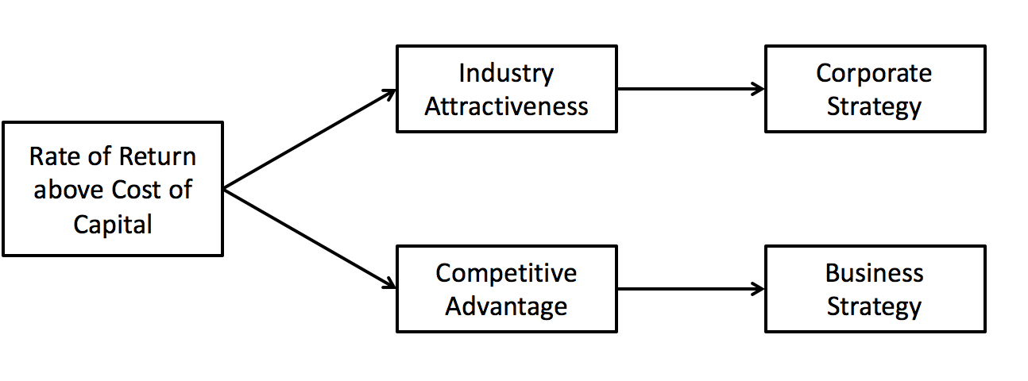

*From:* Robert M. Grant (2002). *Contemporary Strategy Analysis*. Fourth Edition, Blackwell Publishers. Page 23

*Model 2*: Michael Porter’s Five Forces

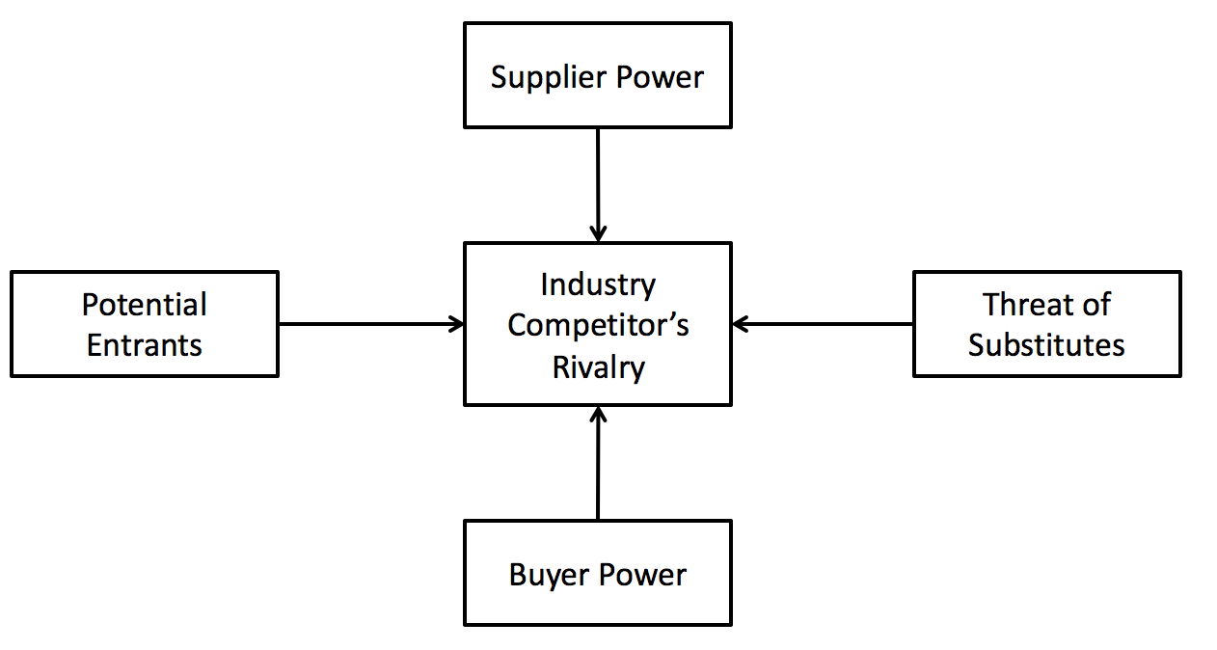

*From:* Michael E. Porter (1980). *Competitive Strategy: Techniques for Analysing Industries and Competitors*. Free Press, New York

*Model 3*: PESTLE Analysis

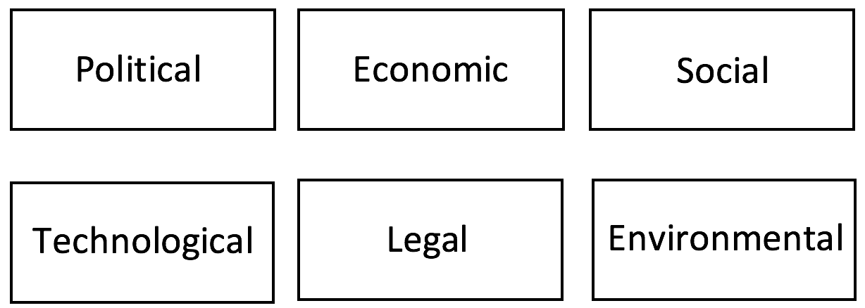

*From:* Francis J Aguilar (1967). *Scanning the Business Environment.* Macmillan, New York

*Model 4:* Principal Flows in Simple Supply Chain

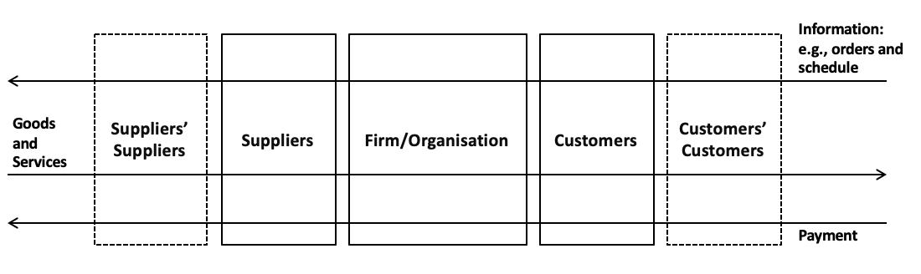

*From:* CIPS (Chartered Institute of Purchasing and Supply) (2010). *Strategic Supply Chain Management.* Stamford